

Group Members:

* Anoushka Panja,
* Subham Dey,
* Nityasundar Mondal,
* Anurag Bandyopadhyay

Roll: 302210501006, 002110501130, 00211501091, 00211501117

Subj: Internet Technology Lab Report (Assignment 5)

Class: BCSE-III

Section: A2

Session: 2023-24

**Question**

***Implement ARP protocol using TCP/UDP Socket as suitable. You may write in a programming language of your.***

**Solution:**

**Client Side:**

import socket  
import sys  
import logging  
  
# Configure logging  
logging.basicConfig(level=logging.ERROR)  # Set logging level to ERROR  
  
# Define server IP and port  
SERVER_IP = '192.168.0.103'  
SERVER_PORT = 12000  # Change this to a valid port number  
  
# Create UDP socket  
client_socket = socket.socket(socket.AF_INET, socket.SOCK_DGRAM)  
  
try:  
    while True:  
        # Get IP address from user  
        ip_address = input("Enter IP address: ")  
  
        # Send ARP request to server  
        client_socket.sendto(ip_address.encode(), (SERVER_IP, SERVER_PORT))  
  
        # Receive ARP reply from server  
        reply_data, _ = client_socket.recvfrom(1024)  
        print(reply_data.decode())  
except KeyboardInterrupt:  
    logging.info("KeyboardInterrupt: Exiting the client program.")  
except Exception as e:  
    logging.error(f"An error occurred: {e}")  
finally:  
    client_socket.close()

**Server Side:**

import socket  
  
# Define server IP and port  
SERVER_IP = '192.168.0.103'  
SERVER_PORT = 12000  
  
# Define ARP table (IP-to-MAC mapping)  
ARP_TABLE = {  
    '192.168.0.103': '00:11:22:33:44:55',  
    '192.168.1.2': 'AA:BB:CC:DD:EE:FF'  
}  
  
# Create UDP socket  
server_socket = socket.socket(socket.AF_INET, socket.SOCK_DGRAM)  
  
# Bind socket to address and port  
server_socket.bind((SERVER_IP, SERVER_PORT))  
  
print("ARP server is running...")  
  
while True:  
    # Receive data from client  
    data, client_address = server_socket.recvfrom(1024)  
    ip_address = data.decode()  
  
    # Lookup MAC address in ARP table  
    if ip_address in ARP_TABLE:  
        mac_address = ARP_TABLE[ip_address]  
        reply_data = f'MAC address for {ip_address} is {mac_address}'  
    else:  
        reply_data = f'No MAC address found for {ip_address}'  
  
    # Send ARP reply to client  
    server_socket.sendto(reply_data.encode(), client_address)

**Output:**

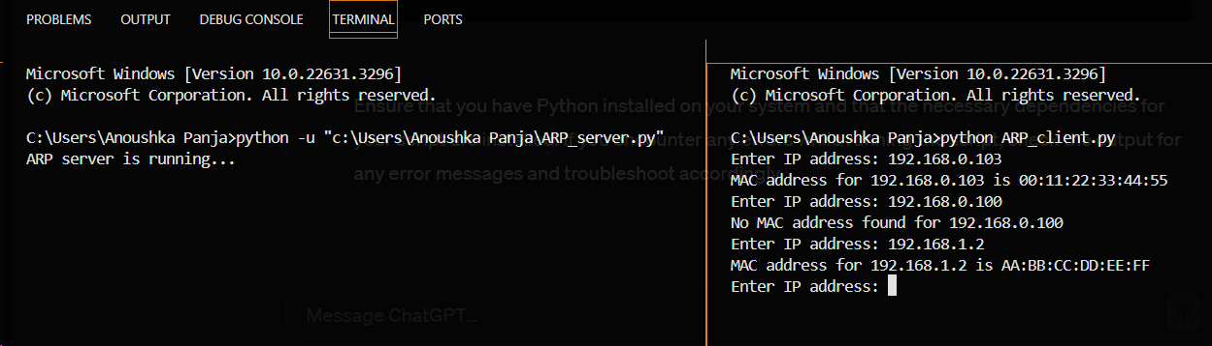

**Discussion:**

**Server:  
ARP Table**: The server maintains an ARP table, which maps IP addresses to MAC addresses. This table is hardcoded in the code for simplicity.  
**Socket Creation**: The server creates a UDP socket, binds it to a specific IP address and port, and listens for incoming requests.  
**Request Handling**: Upon receiving an IP address from the client, the server checks if the IP exists in its ARP table. If found, it sends back the corresponding MAC address; otherwise, it notifies the client that no MAC address is found.

**Client:  
Socket Creation**: Similar to the server, the client creates a UDP socket.  
**User Input**: It prompts the user to enter an IP address.  
**Sending Request**: The client sends the entered IP address to the server.  
**Receiving Response**: It receives the response from the server, displaying the MAC address if found or an appropriate message if not found.